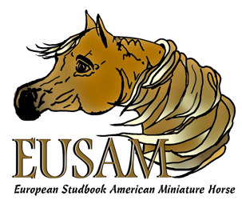
EUROPEAN STUDBOOK
AMERICAN MINIATURE HORSE
REGISTRATION FORM

OWNER(S) OF THE HORSE __________________________________________________________

Address: ____________________________________ City/Zip _____________________________

NAME OF THE HORSE (FOAL) ________________________________________________________

FOALING DATE: (D/M/Y) _______________ HEIGHT _________ CM / INCH

SEX: Stallion Mare Gelding (date gelded: ___________ Gelding certificate required)

SIRE NAME: ___________________________________________ registration number: _____________

DAM NAME: ___________________________________________ registration number: _____________

FOAL INFORMATION: COLOR: __________________ Pinto Roan Appaloosa Dapple (circle if applies)

MANE COLOR: ___________________________ TAIL COLOR: ____________________

WHITE MARKINGS: FACE: _______________________________________________

LEGS: _______________________________________________

CHIP NUMBER: _____________________________

FOR REGISTRATION WE NEED: (ALL INFORMATION BY EMAIL TO: REGISTRATION@EUSAM.NU)
- THIS FORM
- TWO PICTURES OF THE HORSE, ONE FROM LEFT & ONE FROM RIGHT SIDE ( IN JPEG OR PDF)
- IF POSSIBLE, COPY OF AMHA OR AMHR CERTIFICATE
- IF POSSIBLE, THE CHIPNUMBERS BY REGULAR POST

SEND ALL INFORMATION TO: EUSAM
PEELSTRAAT 15
5427 EG BOEKEL
NETHERLANDS

EMAIL: registration@eusam.nu website: www.eusam.nu

COST FOR A PASSPORT: BANKINFORMATION:
Members: € 45,- European Studbook American Miniature Horse
Non-members: € 60,- NL 11 INGB 0009144497
Bic: INGBNL2A

